**Instructions to self-enroll in the FAST List Serv**

On your browser, type <http://listserv.usf.edu/scripts/wa.exe?A0=FAST-LIST>

This page will appear; click “Get Password”

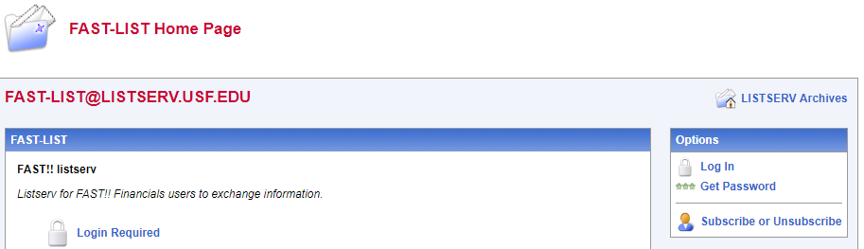

This page will appear; type your email address and create a password; then click “Register Password”



