BIO

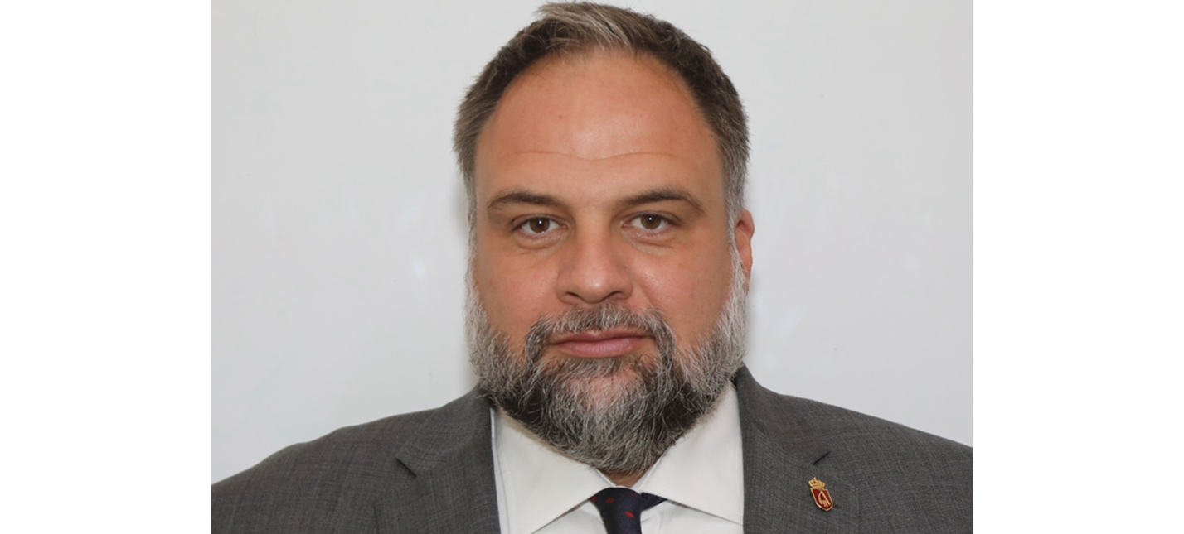
Marko Bajic

Marko Bajic, American Serb, was born in Novi Sad. He earned his Bachelor’s degree in Business Management from Montana State University and the University of Phoenix. Marko earned his Master’s degree in Global Sustainability, Climate Mitigation & Adaption from the University of South Florida, at the Patel College of Global Sustainability.
Marko is currently working as General Manager of The Office of HRH Crown Prince Alexander. In addition, his work involves the United States Department of Defense and OSCE. He is CEO of MLK Team consulting company, which has expertise in sustainable business development and UN Sustainable Development Goals implementation. He is Founder of the Sustainable Tourism Serbia Project and the Serbian Royal Compound Project. Marko also serves as a Crown Council member to HRH Crown Prince Alexander Karadjordjevic. Marko is a United States Navy retiree. He resides in both Belgrade, Serbia, and Saint Petersburg, FL. He is married to Katarina Pesic and they have a son Mark Lazar.

