Supplementary Conditions
OF THE CONTRACT FOR CONSTRUCTION

Project Name: | Project Name
Project Number: | USF-000
University of South Florida, Tampa Campus
Tampa, FL
The project specific Supplementary Conditions of the Contract for Construction is provided herein. Architect/Engineer in consultation with Owner, shall develop these Supplementary Conditions.
Article/Paragraph | Description
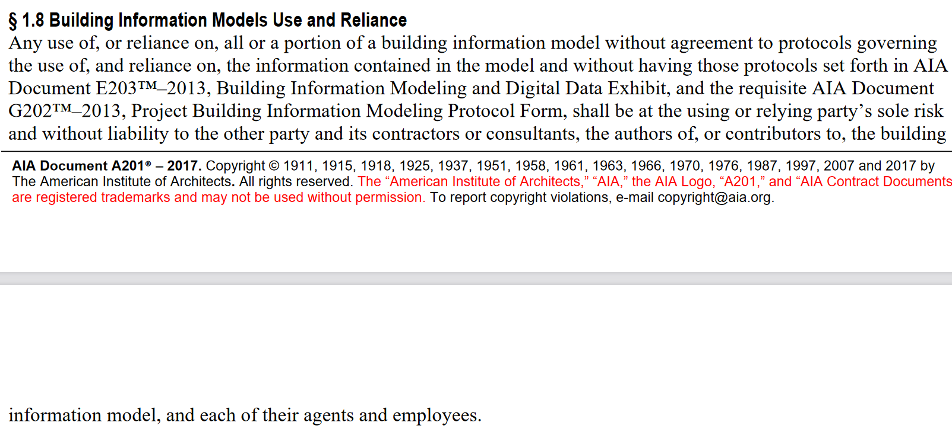
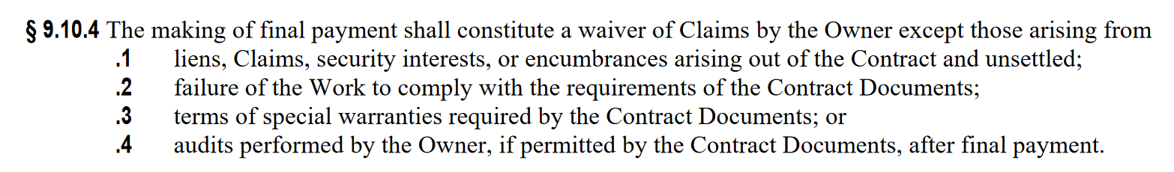
File: UPM-Section J-Supplementary Conditions.docx2.1 Quantity and Format of Documents
The Owner shall provide the Builder with one printed set of Construction Documents, one set of electronic documents (plans and specifications) in PDF format, and one set of BIM files.
(From UF General Conditions)
Must enumerate use and ownership of files.

