- Log into FAST.
- Navigate to USF Home Page>Commitment Control.
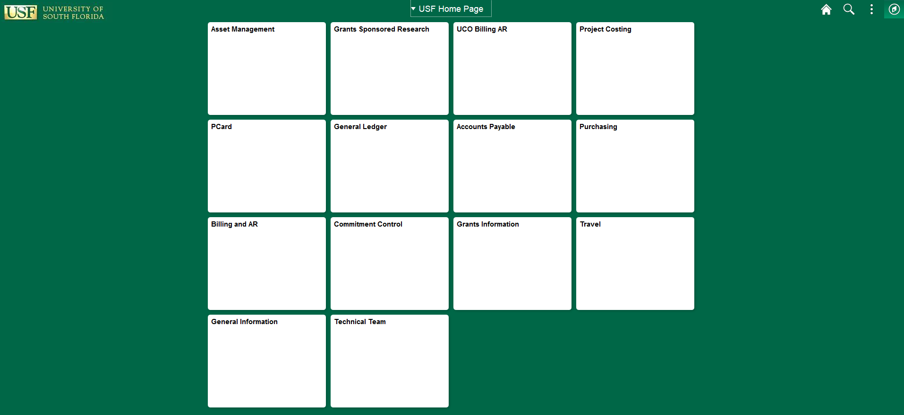

- Click Budget Transfer (Online) from the menu bar on the left.
  - Change the value of the “Business Unit” from TAMPA to USF01 (either by typing in USF01 or by clicking the lookup icon to select USF01).
  - Keep the default value of the “Journal ID” as NEXT.
  - The “Journal Date” defaults to the current date.
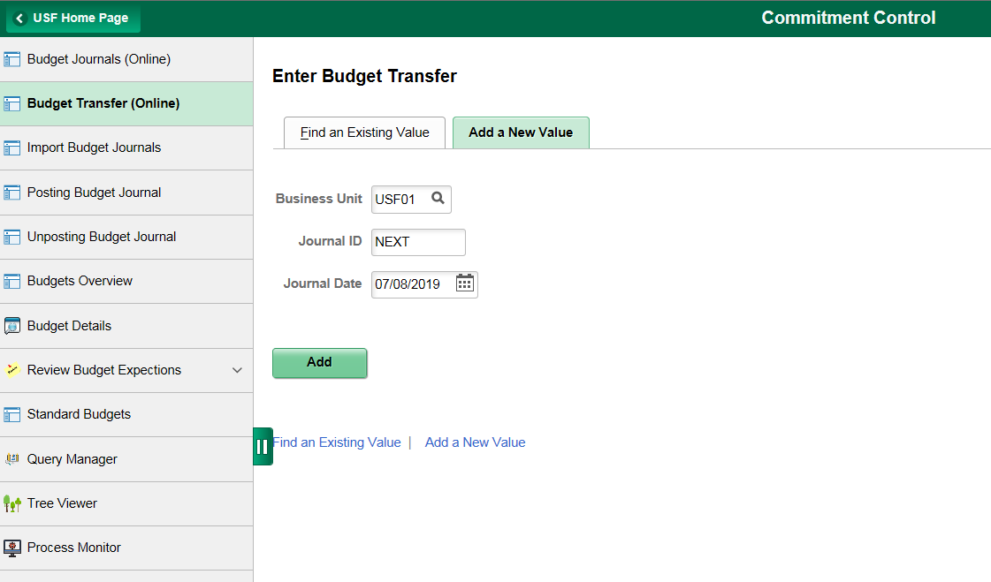
- Click the button

- Enter “Ledger Group”.
  - Select “CC_ORG” for Expense Budget Transfers [Ledger on Budget Line tab (2nd tab) will appear as CC_ORG_BUD]
  - Select “CC_ORG_REV” for Revenue Budget Transfers* [Ledger on Budget Line tab (2nd tab) will appear as CC_ORG_BD]
  - *Security prevents users outside of Resource Management & Analysis (RMA) to post Revenue Budget Transfers. If you are preparing a Revenue Budget Transfer, select “CC_ORG_REV” and follow all of the remaining steps through posting. The final step for posting a Revenue Budget Transfer requires contacting RMA for posting by sending an email to BPA@usf.edu with the budget transfer number.

- Enter “Long Description”
  - Examples include:
    - Budget Transfer from Reserves to Advertising Promotional
    - Funding for computer and phones
    - Funds to cover OPS support for XYZ program
    - Transfer of funds from Reserves to cover room rental for freshman orientation
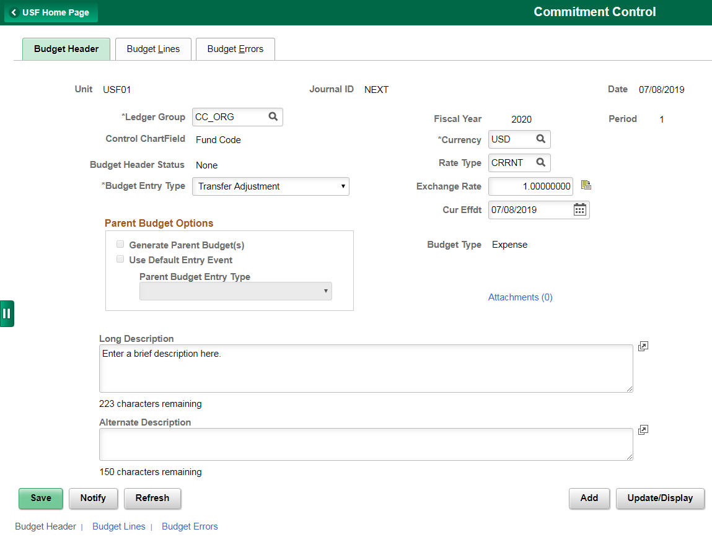

- Click on the tab.

- Enter the Chartfield information and amounts
  - “Budget Period” is the 4 digit fiscal year (e.g. for fiscal year 2019/2020, Budget Period is 2020)
  - Users only have security to post budget transfers for current budget period
  - “Account” field is a 5 digit value that begins with 8
    - Budget Accounts for Expenses start with 88
    - Budget Accounts for Revenues start with 84, 85 or 86
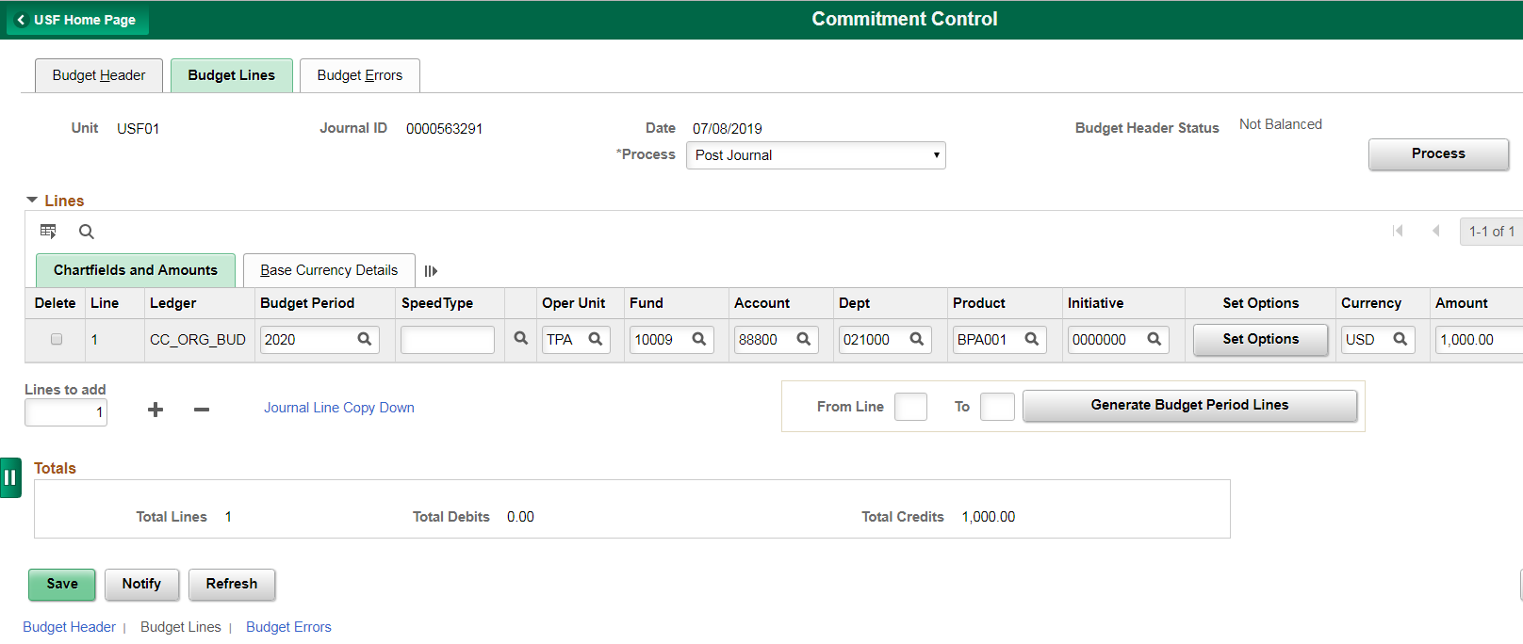

- Click the save button to generate a Journal ID. Make note of the Journal ID. This will allow you to come back and finish your journal if you are interrupted.

- Click the button below the line(s) to add additional line(s).

- Total Debits must equal Total Credits.
  - Positive amounts will increase your budget; Negative amounts will decrease your budget.
  - In this example, Budget is moved from 88800 (Other Operating Expenses) to 88500 (Repairs/Maintenance/Renovation).
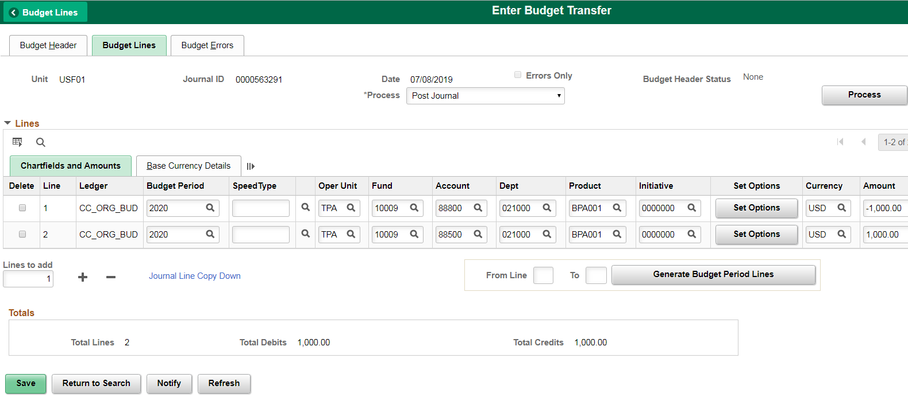

- Verify chartfield strings are correct.

- Verify Total Debits = Total Credits.

- For Expense Budget Transfers, click the button.

- Click the button to post this journal.
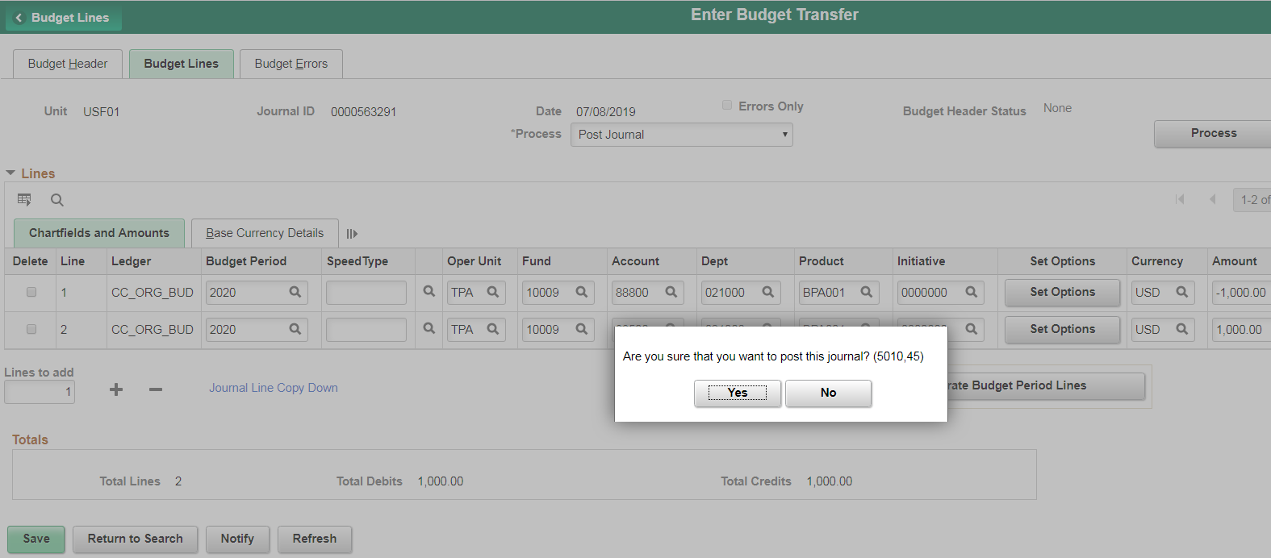

- If the posting process is completed within 2 minutes, this screen will appear:
  - The Budget Header Status has changed from “None” to “Posted”.
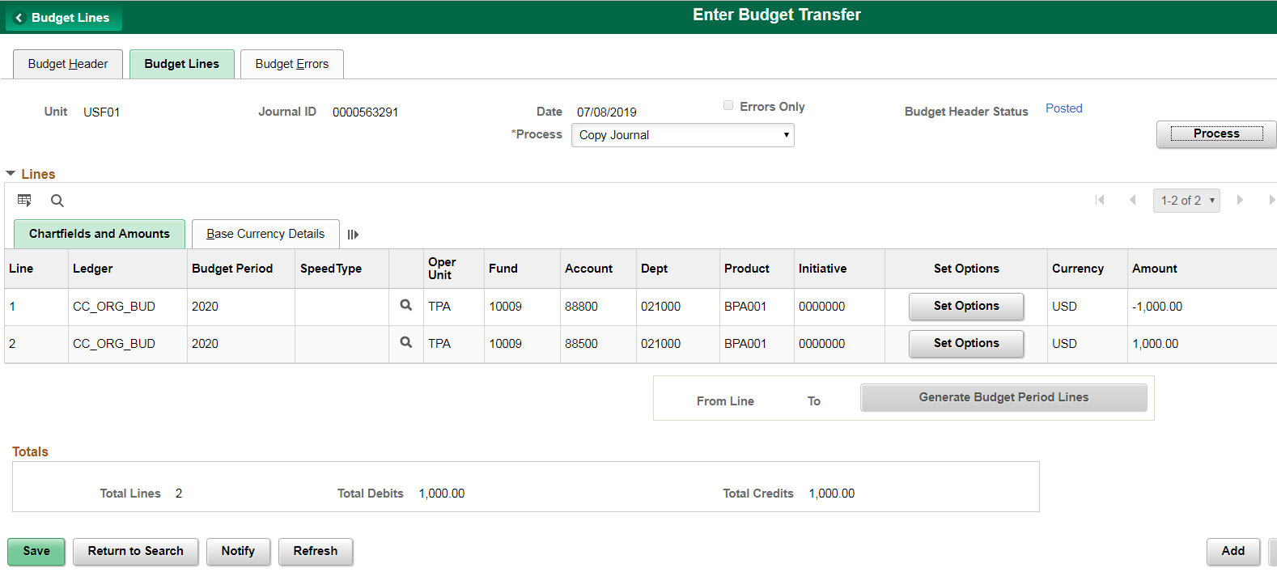

- If the budget journal could not be posted within 2 minutes, you will be prompted with a screen similar to the one below:
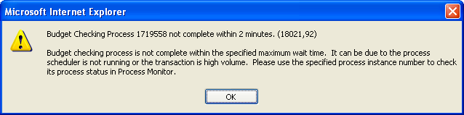

- Click the button.

- Navigate to USF Home Page>Commitment Control>Process Monitor
  - To access the Process List tab, click the button until the journal posting is completed (the Run Status becomes Success and Distribution Status becomes Posted).
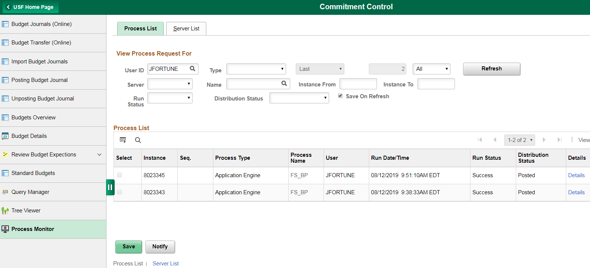

- After your budget journal is posted, it cannot be modified.

To review a completed budget journal or to pull-up an incomplete journal and continue working

- Log into FAST.

- Navigate to USF Home Page>Commitment Control.

- Click Budget Transfer (Online) from the menu bar on the left.
  - Click the “Find an Existing Value” tab.
  - Enter Business Unit = USF01, and enter the journal number to review or to work on.
  - Click the button.
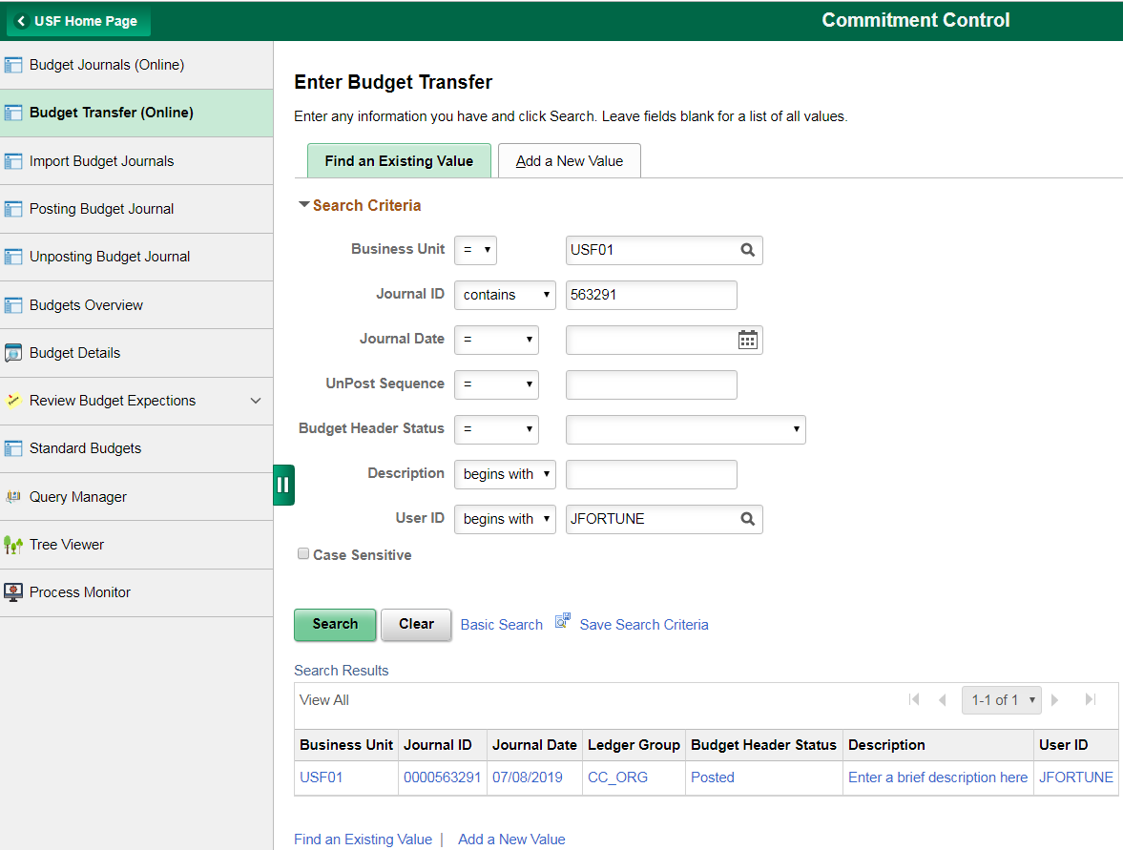

- Click on the search result.

- Notice that the Budget Header Status is “Posted”.
  - If you saved and have not posted your journal you would see “None” instead.
  - At this point you can complete your previous journal by moving to Step #8 and finish all steps until the journal is posted at Step #15.

You may call RMA at 974-2393 or email BPA@usf.edu for additional assistance.

