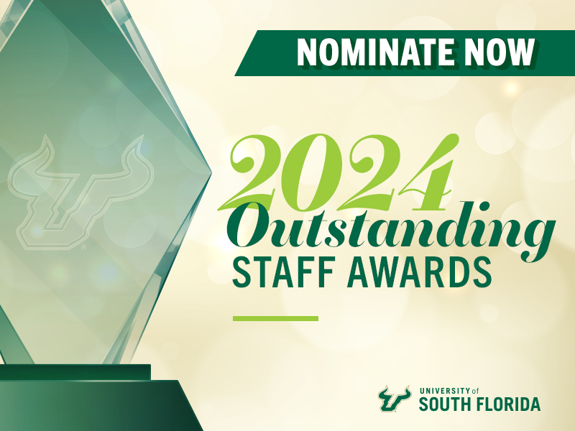
The University of South Florida is dedicated to meeting the needs of our diverse student population through a high-quality and highly relevant curriculum and a steadfast spirit of service to local and global communities through the development of strategic partnerships and highly relevant applied research. Our mission, vision, aspirations, and goals inform all aspects of both the strategic planning process and its implementation—reaffirming our commitment to excellence in teaching and learning, research and scholarly activity, community engagement, and equity in diversity and inclusion. Taken together, they serve as our blueprint for driving strategic focus and institutional commitments.
Award Criteria
The Outstanding Staff Awards – for both individuals and teams – are focused on recognizing employees who demonstrate "above and beyond" performance excellence and support the values in USF's Strategic Plan – In Pursuit of Excellence.
- Inquiry through: High-quality, multidisciplinary education, and excellence in teaching and learning. High-impact scholarship, research, and creative pursuits. Success and achievement of its students, faculty, staff, and alumni. Collegiality, collaboration, academic freedom, viewpoint diversity, and an institutional commitment to the open exchange of ideas, divergent opinions and philosophies, rigorous debate, grounded in the principles of civil discourse, and professional responsibility.
- Innovation through: Exploration of new technologies to create efficiencies and solve problems. A culture of learning, growth, entrepreneurial spirit, and partnerships. First-class administrative and physical infrastructure to support the university’s education and research mission. An agile, flexible, and proactive multi-campus community that develops curricula and programs to meet rapidly changing community and global needs.
- Integrity through: Shared governance within all components of the institution. Transparency and accountability of the university’s operations. Affordable and accessible education for all. Social, economic, and environmental sustainability at the local and global levels.
- Inclusion through: Diversity of students, faculty, and staff in safe campus environments. Respect and recognition of each individual through a commitment to justice, equity, and anti-racism. Community engagement and public service. A welcoming campus life with broad academic, cultural, and athletic opportunities.

Award Eligibility
All staff and administrative employees (in a regular, established position) continuously employed from July 1, 2023, through June 30, 2024, are eligible for nomination. To continue meeting eligibility, an employee must be employed in an established position thirty days before the awards ceremony to receive the award. Time spent on temporary (OPS) assignments will not count towards eligibility. Faculty and temporary employees (student and non-student) are not eligible to be nominated for the Outstanding Staff Awards. However, faculty and temporary employees (student and non-student) are welcome to participate in nominating staff and administrative employees for recognition.
Individual Award Nomination
Submit a nomination sharing recognition of a single employee's "above and beyond" performance and support the values in USF's Strategic Plan.
Prompts
- For the value that you selected above, please explain how the employee's actions/performance represent that value. (Up to 250 words)
- Provide an example of how this individual's contributions go above and beyond performing their essential/core job functions (above and beyond may reflect attitude, behavior, and general approach to their work, what sets this employee apart from peers, etc.). (Up to 250 words)

Team Award Nomination
Submit a nomination for the recognition of a team of employees for its execution of a project, plan and/or initiative that:
- Break silos across OneUSF and incorporates a team from across two or more unites and/or across two or more campuses,
- Demonstrates above and beyond performance, and
- Supports the values in USF's Strategic Plan - In Pursuit of Excellence.
How many employees can be included in a team nomination?
- To support our OneUSF approach, there is no longer a limit on how many employees may be nominated for a team award, but each member should have contributed significantly to the team.
Prompts
- Briefly describe the team's specific execution of a project, plan and/or initiative. (Up to 250 words)
- For the value that you selected above, please explain how the team's actions represent that value. (Up to 250 words)
- Provide an example of how this team's contributions exemplify "above and beyond" performance (above and beyond may reflect attitude, behavior, and general approach to their work, what sets this team apart from others, etc.). (Up to 250 words)

NOTE: The prompts above should be limited to 250 words each. To check the number of words, highlight the text, and then review the number of words in the lower left-hand corner of the Word document.

