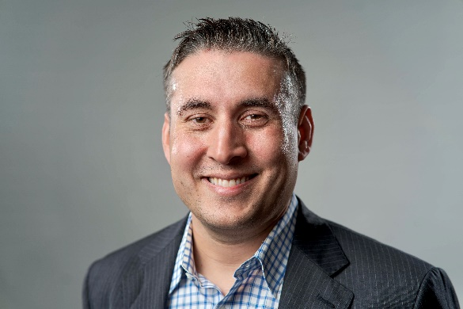

CALEB QUAID, MBA, LEED AP BD+C
Founder / Regenerative Shift

Caleb Quaid is a Regenerative Consultant and founder of Regenerative Shift (regnerativeshift.com), an environmental consulting firm focusing on assisting businesses and communities with the transition to regenerative practices. In 2022, with Regenerative Shift, Caleb worked with Raymond James Stadium in Tampa, FL to plant the first regenerative planting project in North American professional sports, with an 1,100-foot living fence of bamboo and native plants. He focuses on projects with mainstream, high-profile businesses, as a means to energize the regenerative movement into everyday conversations.

Prior to forming Regenerative Shift in 2021, Caleb spent 12 years working the NFL, mostly with the Tampa Bay Buccaneers in a senior operations and project management role. During his time with the Buccaneers, he oversaw stadium operations, game operations, facilities, and construction management projects totaling over $200MM in renovations and new construction.

Caleb’s passion for regeneration blends into his personal and social life. He and his two sons, Kobe and Atlas, operate a small front-yard permaculture community garden from their home in Tampa, FL, where neighbors can pick their own produce to enjoy.

