BIO

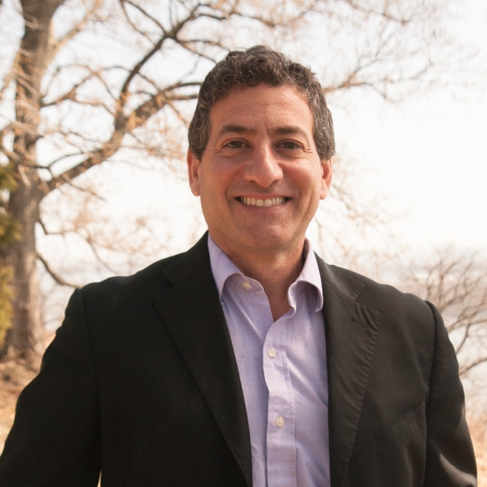

Dr. TH Culhane

Dr. Thomas Culhane is an Associate Professor at the Patel College of Global Sustainability and directs the graduate program in climate mitigation and adaptation. Culhane got his PhD from UCLA in Urban Planning, living with and working on solar energy and waste management projects with the trash recycling communities of Cairo Egypt, and his master’s in regional and international development working on agroecology in Guatemala. His undergraduate studies at Harvard University included a year in the primary rainforests of Borneo, working on community ecology issues with hunter-gather tribes.

