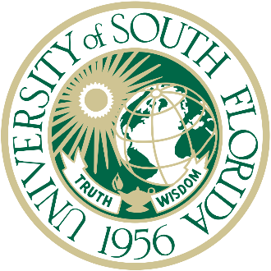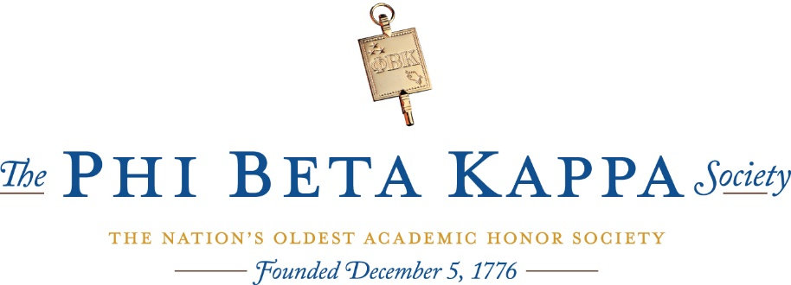

The University of South Florida is proud to announce its class of Phi Beta Kappa inductees for the year 2023. These accomplished students and their major(s) are listed below.

Name | Major(s)
Lucia Andrews | Psychology, Biomedical Sciences
Emilia Araoz | World Languages & Cultures
Kelsey Barton | Studio Art
Elizabeth Beatty | Psychology
Madison Bonaventura | Psychology
Madeline Brand | Interdisciplinary Social Sciences
Ginelle Brown | World Languages & Cultures
Rufei Chen | Biomedical Sciences
Thalia Crespo Parron | Biomedical Sciences
Krisztian Cseh | Anthropology, Accounting
David Ditz | Biomedical Sciences, Psychology
Avery Fleishman | Biomedical Sciences
Jessica Fueyo | Political Science
Jason Giese | History, World Languages & Cultures
Sarah Harding | Communication
Bridget Hartung | Environmental Science and Policy
Jessica Heintz | Biomedical Sciences
Truman Hoang | Political Science
Leah Hoopes | Sociology
Anna Jablonska | Biomedical Sciences
Manuela Jaramillo | Biomedical Sciences
Bethany Jowers | Biomedical Sciences, World Languages & Cultures
Christian Kaplan | Biomedical Sciences
Heaven Knox | Psychology
Elizaveta Kuzmina | International Relations, Economics
Mikayla Leaf | Biology
Karina Lowyns | Biology, Psychology
Mikayla Maiorino | Psychology, World Languages & Cultures
Suhaas Mandala | Biomedical Sciences
Gayathri Mannem | Biomedical Sciences
Myles McCants | Political Science
Kaylie Miller | Biomedical Sciences, Psychology
Sophia Montejo | Psychology
Connor Murray | Psychology, Health Sciences
Corey Naftaniel | Psychology
Kavita Parbhoo | Cellular and Molecular Biology
Ankit Patel | Biomedical Sciences, Sociology
Frances Perez | Microbiology
Daelyn Quinn | Cellular and Molecular Biology, World Languages & Cultures
Maria Quintana Goicoechea | Biomedical Sciences
Angitha Reji | Biomedical Sciences, World Languages & Cultures
Payton Richardson | Communication
Jasmine Robins | Biomedical Sciences
Myriam Gabriela Rodriguez | International Relations, Anthropology
Christian Sabbagh | Biomedical Sciences, Political Science
Sammie Schulman | Integrated Public Relations, Advertising
Andersen Shigo | Biomedical Sciences
Grace Sinclair | Psychology
Kaleb Smallwood | Geology
Kailyn Smith | Biomedical Sciences, Psychology
Matthew Stoner | Computer Science and Engineering
Ashlee Torres | English
Lauren Trumbull | Integrative Biology
Nafisa Uddin | Biomedical Sciences, International Relations

