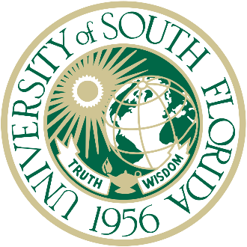

The University of South Florida is proud to announce its class of Phi Beta Kappa inductees for the year 2024. These accomplished students and their major(s) are listed below.

Name | Major(s)
Tehami Ammad | Biomedical Sciences & Philosophy
Natalie AmRhein | Biology and Environmental Science & Policy
Eva Austin | Environmental Science & Policy
Catherine Bricker | Cell & Molecular Biology and World Languages & Cultures (French)
Sasha Brown | Biology and World Languages & Cultures (Spanish)
Nicholas Brunetti | Biomedical Sciences
Emma Burdick | Chemistry
Neige Deangelis | Music Studies and Biomedical Sciences
Carleena Michelle Deforges | Environmental Science & Policy
Gabriela Demeglio | Psychology
Varun Dhaka | Biomedical Sciences & World Languages & Cultures (Spanish)
Andrew Drotleff | Environmental Science & Policy
Ayslin Edwards | Environmental Science & Policy and World Languages & Cultures (Spanish)
Shae-Lynn Gibbs | Language, Speech, and Hearing Sciences
Kayleigh Gonzalez | Biology
Sarai Guzman Cartagena | Interdisciplinary Social Sciences
Zachary Jacobson | Mathematics
Rahul Jain | Biomedical Sciences
Kavery Kallichanda | Biomedical Sciences
Claudia Laux | Psychology
Ruth Liu | Health Sciences and World Languages & Cultures (Spanish)
Jose Masso Maldonado | Biomedical Sciences
Morgan Mathews | Environmental Science & Policy
Adam Nigels | Biology
Joseph Pereira | Health Sciences
Brandon Pham | Biomedical Sciences
Sasha Post | Cell & Molecular Biology
Ishali Rajguru | Health Sciences
Hasan Raza | Economics and Biomedical Sciences
Megan Reddy | Biomedical Sciences
Dora Rodriguez | Biomedical Sciences & World Languages & Cultures (Spanish)
Jeremy Rutter | Computer Science
Sierra Smith | Civil Engineering
Lily Smith | Psychology
Deeksha Sridher | Biomedical Sciences
Kaitlin Strawn | History
Joshua Szabo | Biology
Guillermo Trastoy | Biology and Psychology
Otilia Trejo-Soto | Psychology
Joshua Vilgorin | Psychology
Christopher Vo | Health Sciences
Lindsay Wilson | Language, Speech, and Hearing Sciences
Nora Wolfgang | Biomedical Anthropology
Lingxi Zhou | Computer Science
Ethan Cross Zulueta | Biomedical Sciences & World Languages & Cultures (Spanish)

