PERT Certifiers’ Communication Sample:

Dear (insert i.e. Dr. Lewis:)
The (insert Summer 2023) PERT effort reports (period from insert i.e. 05/06/23-08/06/23) are now available for your review.
The deadline is (insert i.e. 11/17/2023); however, if you could get this done as soon as possible, we would appreciate it. Your I.D. is: (insert i.e. 0000003907)

Below is an overview of the effort report detail for the PER reports needing review and certification:
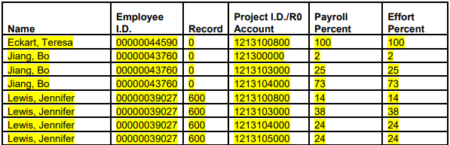

As a reminder, certification training for PERT effort reports is available online at the following link:
https://usfemployeelearning.catalog.instructure.com/browse/compliance-training/courses/pert-certifier-training

Thanking you in advance and please let me know if I can be of further assistance or clarify any additional questions you may have regarding these PERT reports.

Regards,

“PERT i.e.” Please Reminder:

Dear Dr. Larsen:

The Summer 2023 PERT effort reports are now available for your review. The deadline is Friday, November 17th: however, if you could get this done as soon as possible, we would appreciate it. Your I.D. is: 00000041669.
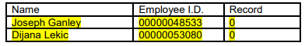

If you have any questions, please let me know and thanks in advance for your assistance.

Regards,

