Reminder Template (replace the highlighted information with the pertinent information)

Dear (insert i.e. Dr. Lewis:)

The (insert i.e. Fall 2023) PERT effort reports are now available for your review. The deadline is November 17, 2023: however, if you could get this done as soon as possible, we would appreciate it. Your I.D. is: (insert i.e.00000041669.)
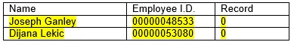
If you have any questions, please let me know and thanks in advance for your assistance.

Regards,

